**DEPARTMENT: SOFTWARE ENGINEERING (BSE)**

**SUBJECT: OBJECT ORIENTED SOFTWARE ENGINEERING.**

**SECTION: 4D**

**SUBMITTED TO SIR JAWAD KHAN**

**SUBMITTED BY**:

|  |  |  |
| --- | --- | --- |
| *SERIAL NO.* | *NAME* | *REGISTRATION NUMBER* |
| *01.* | ***ZAKIR FAYYAZ*** | ***FA20-BSE-166*** |
| *02.* | ***RIZWAN SHAH*** | ***FA20-BSE-167*** |
| *03.* | ***MARIA MANZOOR*** | ***FA20-BSE-161*** |

**Project name: Health Care Management**

**Description:**

* Our project is about health care management in which the patient can take appointment with doctor. The Appointment Can be physical or online (video call). Patient can ask for the prescription
* Patient Can order medicine.
* Patient can book lab test
* Patient can Search for nearby hospitals and laboratory
* Doctor Can see scheduled meeting
* Doctor Can answer to the patient Question
* Doctor can see the lab reports
* pharmacists can accept order from patient and delivered the medicine to the given address
* Lab Technician can accept lab order and send lab report
* Admin can manage the system and database

**Objects in our Project**

* Patient
* Doctor
* Pharmacist
* Lab Assistant
* Admin
* Medicine
* Laboratory
* Pharmacy
* Hospital
* Report
* Order
* Lab Test
* Payment
* Stored data
* Prescription
* Appointment
* Book test
* mode

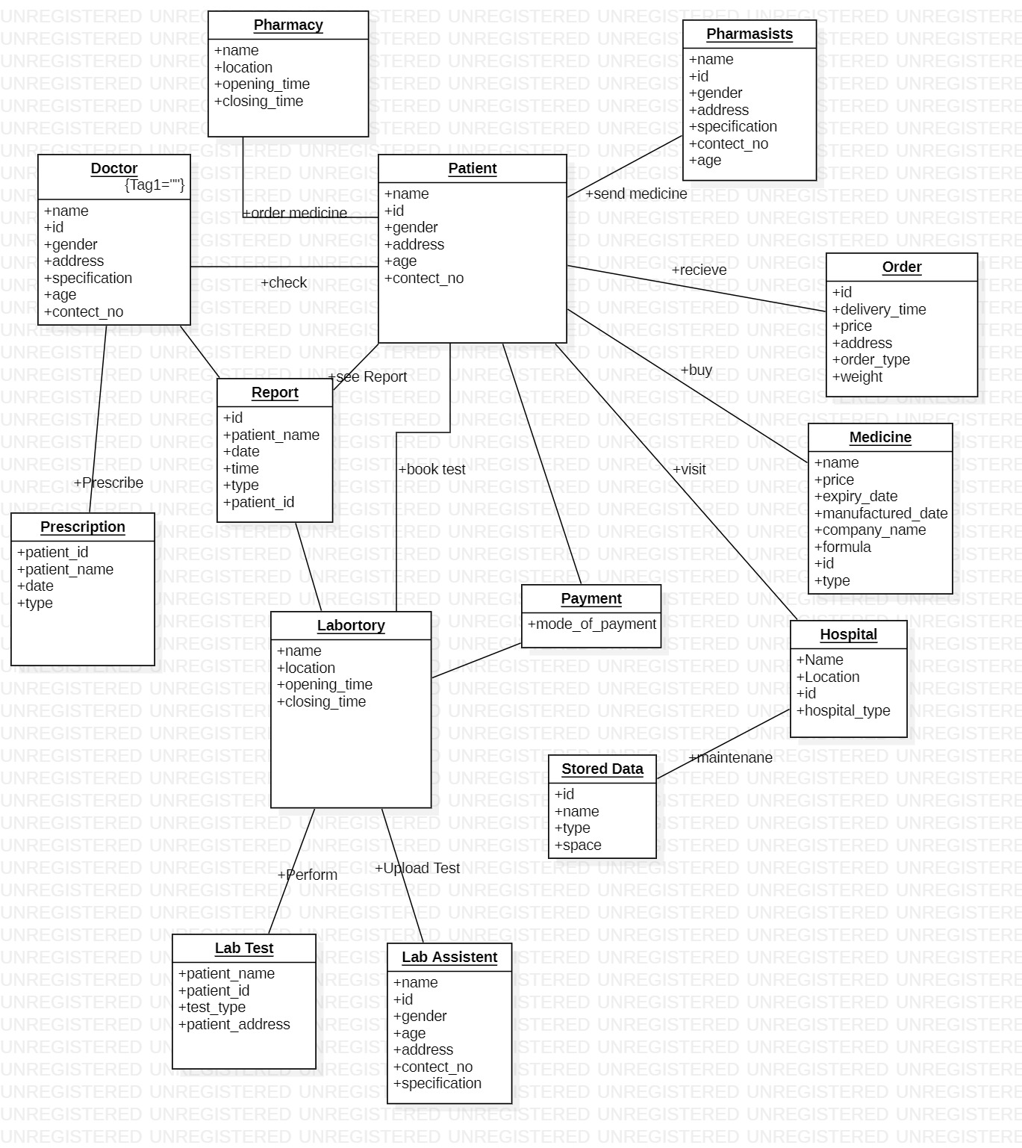**Domain Model**